**Laptop Request Catalog Item**

Submitted by

**Team Leader**

Sewdha S (910022104033)

**Team Members**

Yasodha N (910022104036)

Magesh Sri A (910022104050)

In partial fulfilment for the award of the degree

**BACHELOR OF ENGINEERING**

**in**

**COMPUTER SCIENCE AND ENGINEERING**

NAAN MUDHALVAN LAB

ANNA UNIVERSITY REGIONAL CAMPUS MADURAI-625-019

**ANNA UNIVERSITY: CHENNAI 600 025**

**NOVEMBER 2025**

Supervised by

**Dr. Srie Vidhya Janani, M.E., Ph.D.,**

**BONAFIDE CERTIFICATE**

This is to certify that the project report titled **"** **Laptop Request Catalog Item"** is the Bonafide work of **Swedha S (910022104033), Yasodha N (910022104036), Magesh Sri A (910022104050)** who carried out the project work under my supervision in the Naan Mudhalvan Lab.

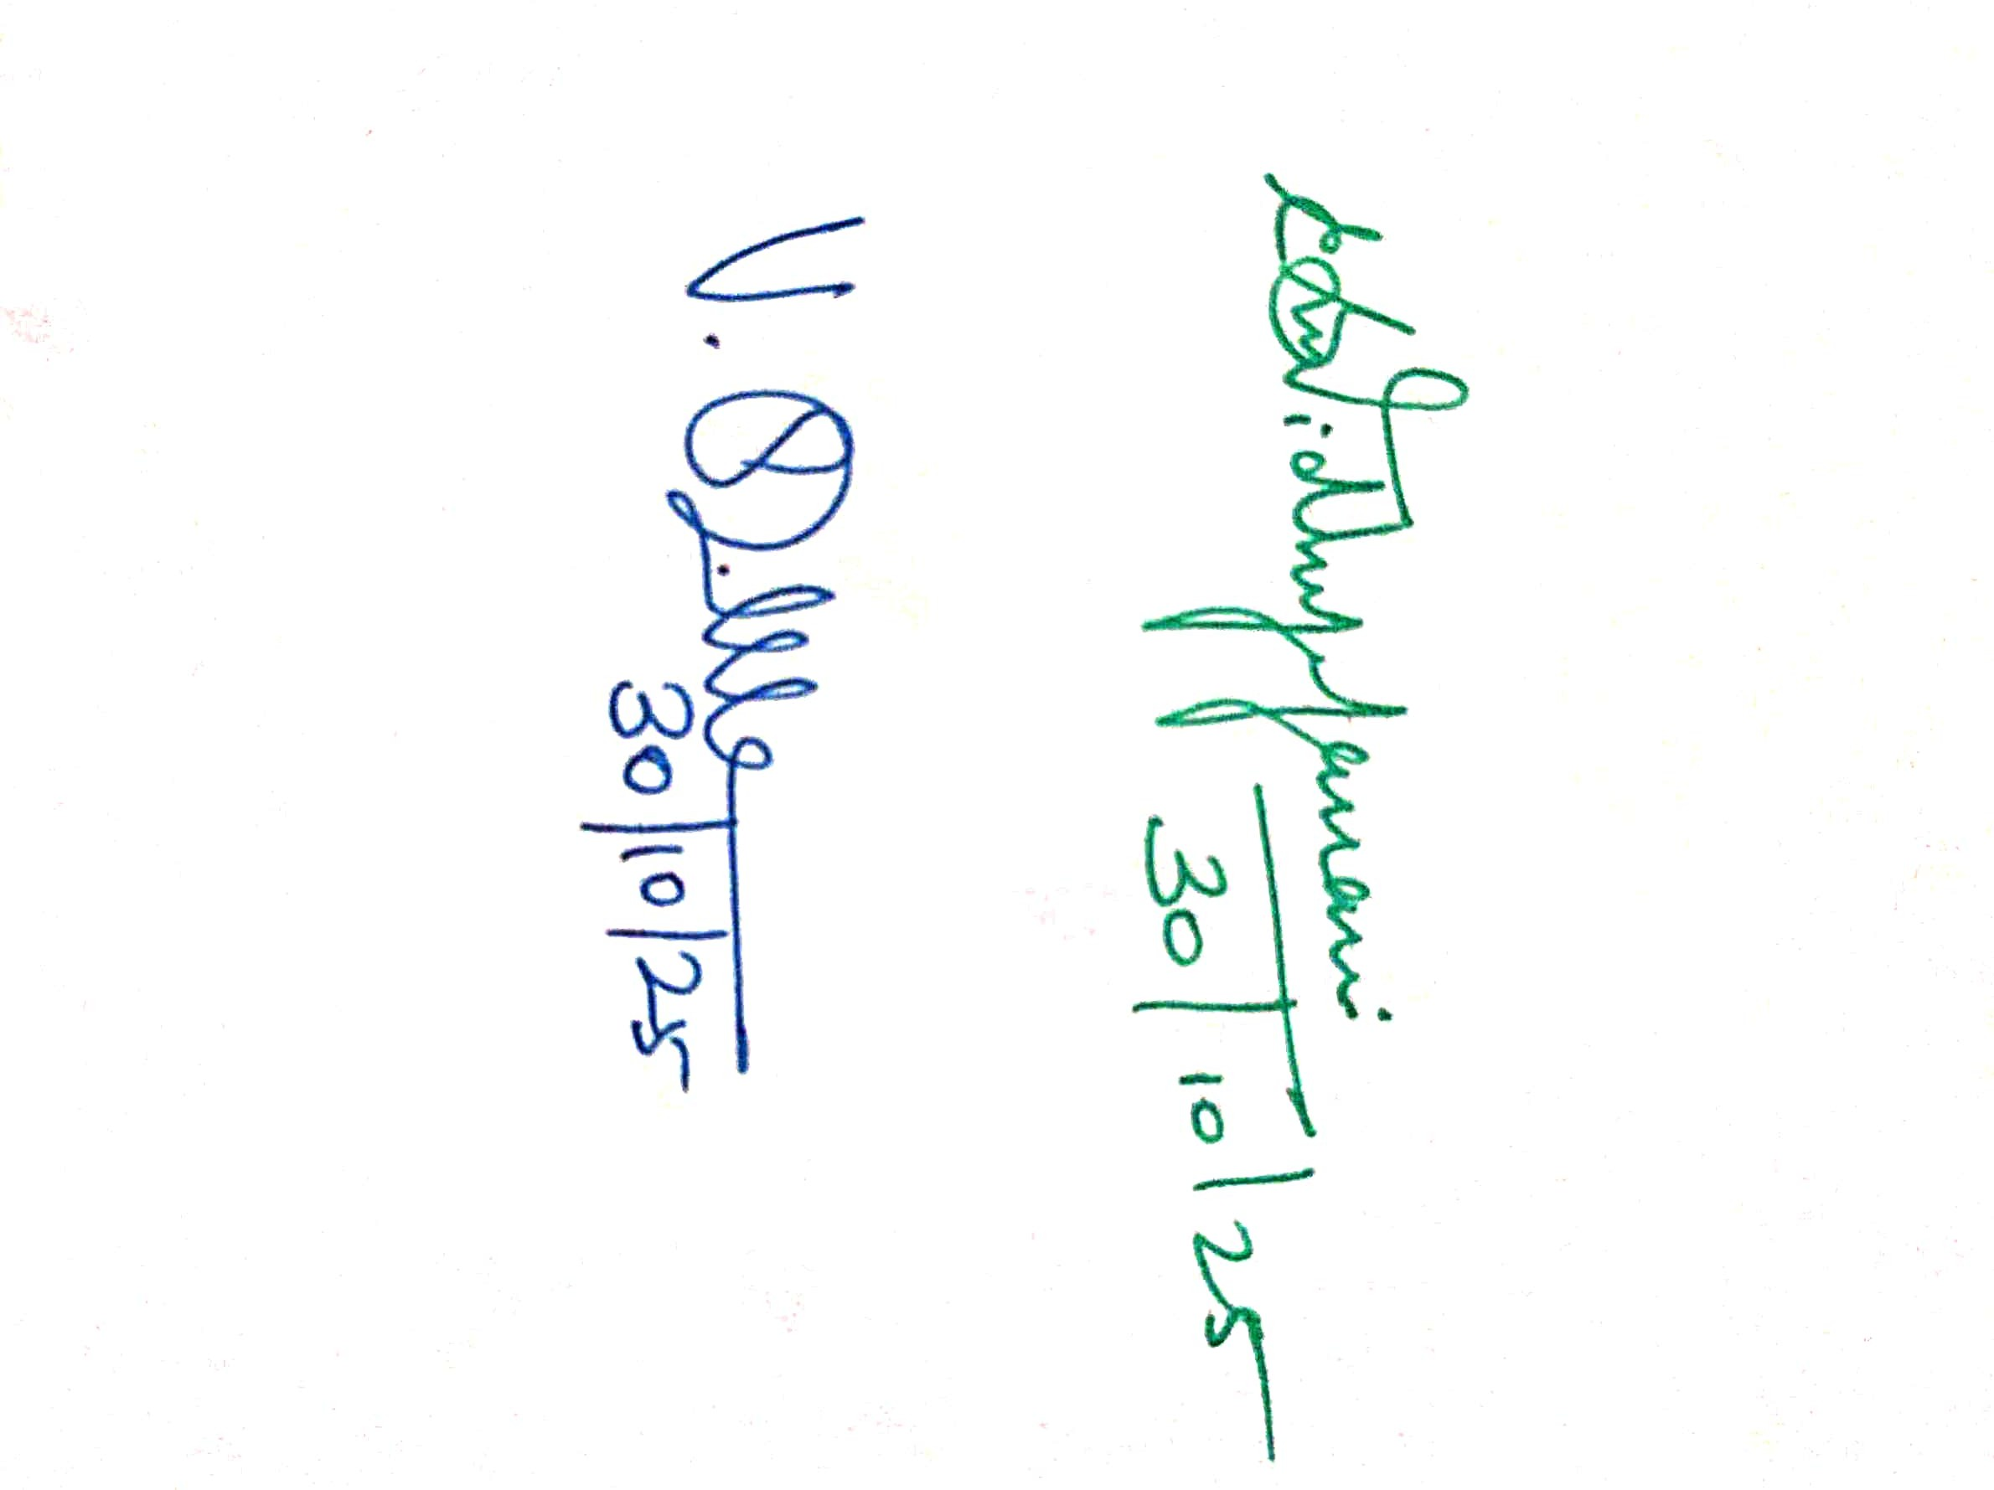

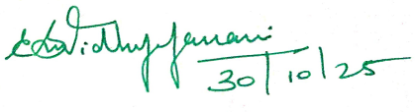

**SIGNATURE SIGNATURE**

**HEAD OF THE DEPARTMENT FACULTY**

Department of Computer Science and Engineering,

Anna University Regional Campus Madurai-625-019

**ACKNOWLEDGEMENT**

I extend my heartfelt gratitude to **Dr. Srie Vidhya Janani**, **M.E., Ph.D.,** Faculty Incharge of Naan Mudhalvan Lab, for her guidance and support throughout this project. I also thank my peers and family for their encouragement, without which this project would not have been possible.

I am deeply grateful to **Dr. V. Sasikala, M.E., Ph.D.,** Head of the Department, for her constant support and guidance.

I extend my sincere thanks to all teaching and non-teaching staff of the Department of Computer Science and Engineering and my peers for their support and encouragement.

Finally, I thank my family and friends, whose encouragement and patience motivated me to complete this project successfully.

**Team Leader Swedha S (910022104033)**

**Team Members Yasodha N (910022104036) Magesh Sri A (910022104050)**

**ABSTRACT**

The Laptop Request Catalog System developed on the ServiceNow platform aims to automate and optimize the process of requesting, approving, and managing laptop assets within an organization. The system enables employees to submit laptop requests through a self-service catalog, while managers and IT administrators can efficiently track approvals, asset availability, and delivery status. By integrating IT Operations Management (ITOM) functionalities, the system ensures intelligent monitoring, discovery, and management of hardware assets throughout their lifecycle.

Leveraging ServiceNow’s powerful automation, workflow, and integration capabilities, the system provides a seamless experience with real-time updates and accurate asset tracking through the Configuration Management Database (CMDB). A customized dashboard presents insightful reports and analytics on asset utilization, request trends, and inventory health, enabling data-driven decision-making. The platform also ensures scalability, security, and compliance with organizational IT policies.

By offering a centralized, digital solution for laptop provisioning, this project enhances operational efficiency, reduces manual intervention, and ensures timely hardware delivery. Ultimately, the Laptop Request Catalog System streamlines IT asset management, improves user satisfaction, and supports the organization’s goal of achieving smarter and more automated IT operations

**Problem Statement:**

The In many organizations, the process of requesting and allocating laptops for employees is time-consuming, inefficient, and prone to manual errors. Traditional methods often involve multiple approval layers, email communications, and offline tracking, leading to delays in asset provisioning and lack of visibility into inventory status. Additionally, IT teams struggle to maintain an updated record of available assets, resulting in poor resource utilization and higher operational costs.

There is a growing need for an automated, transparent, and integrated system that can streamline laptop requests, approvals, and asset management while providing real-time tracking and analytics.

**Objectives:**

* **To develop** an automated Laptop Request Catalog on the ServiceNow platform that allows employees to easily request laptops through a self-service portal.
* **To integrate** IT Operations Management (ITOM) features for real-time asset discovery, monitoring, and lifecycle management through the Configuration Management Database (CMDB).
* **To design** an approval workflow that ensures quick and transparent processing of laptop requests with minimal manual intervention.
* **To provide** a centralized dashboard for tracking laptop inventory, request status, and asset utilization metrics.
* **To enhance** operational efficiency and reduce processing time for laptop allocation through intelligent automation.

**Skills:**

**TASK INITIATION**

**Milestone 1: Setting up ServiceNow Instance**

**Activity:** Setting up ServiceNow Instance

1. Sign up for a developer account on the ServiceNow Developer site “https://developer.servicenow.com”.
2. Once logged in, navigate to the "Personal Developer Instance" section.
3. Click on "Request Instance" to create a new ServiceNow instance.
4. Fill out the required information and submit the request.
5. You'll receive an email with the instance details once it's ready.
6. Log in to your ServiceNow instance using the provided credentials.
7. 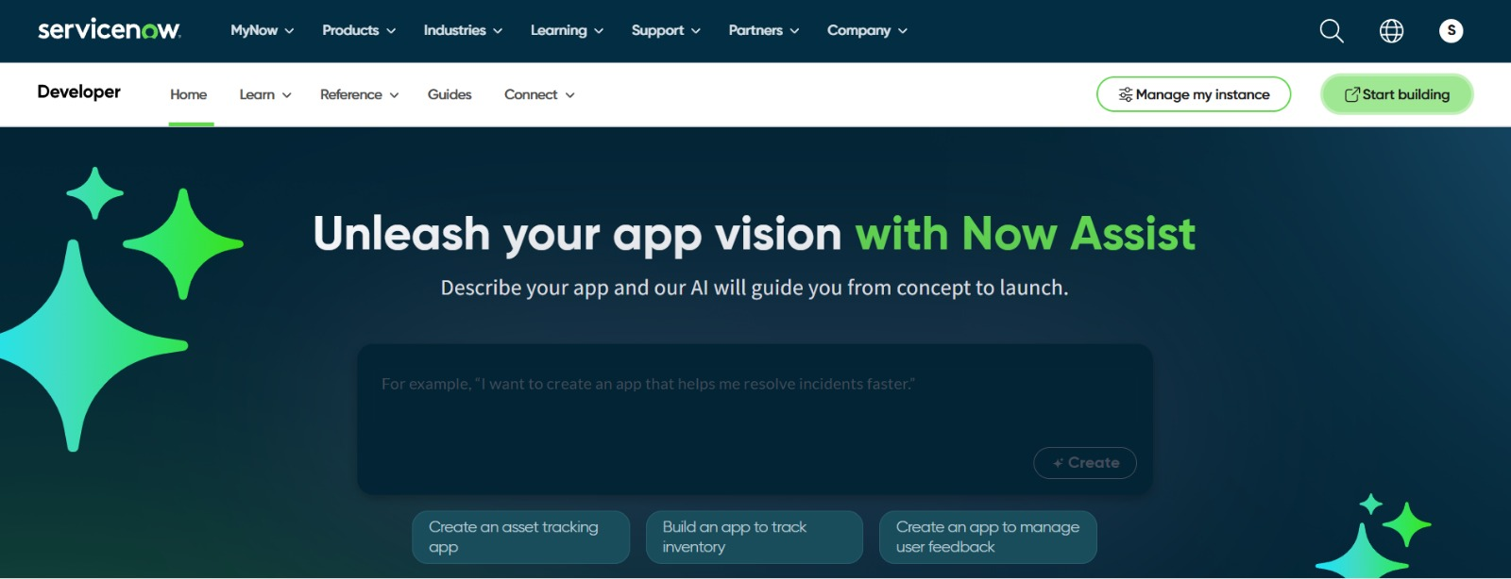Now you will navigate to the ServiceNow.

**Milestone 2: Creation of New Update Set**

**Activity:** Creation of New Update Set

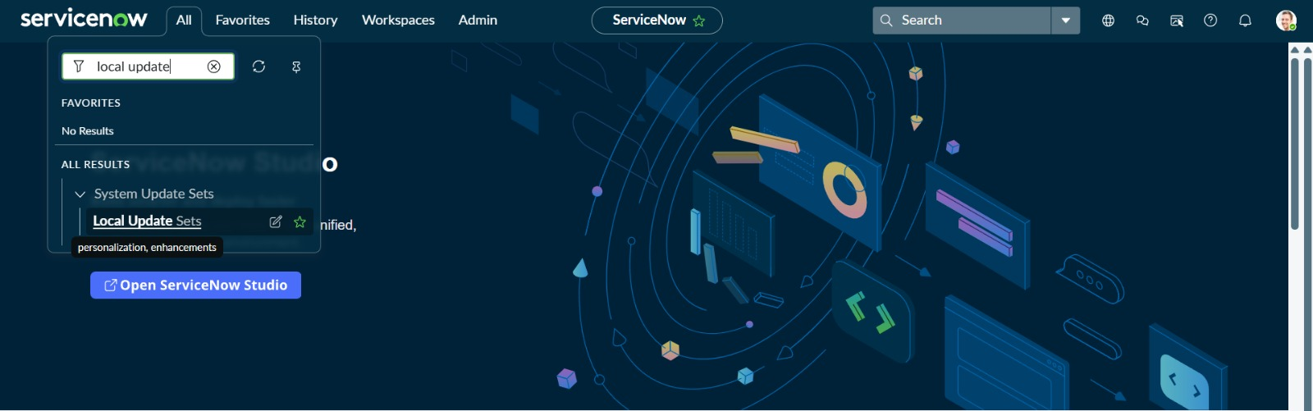

Go to All >> In the filter search for Local Update set > click on New

1. Enter the Details as:

Name: Laptop Request 3

1. Then click on Submit and Make current

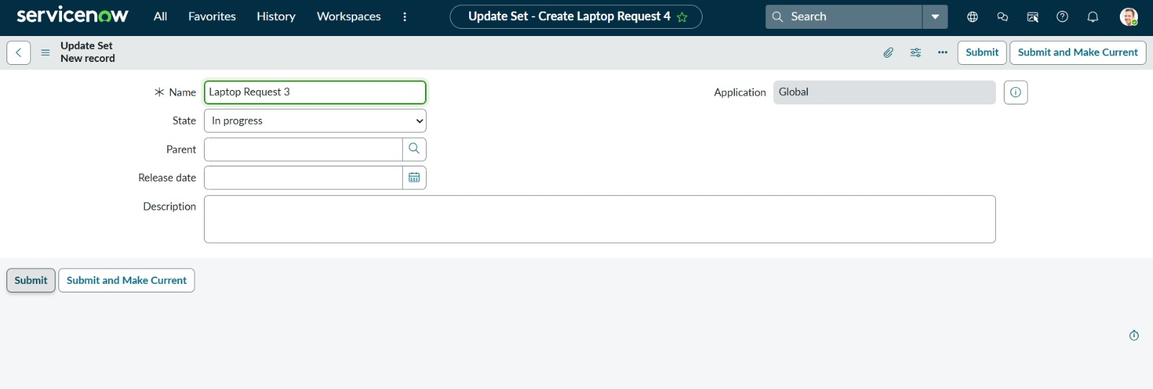

**Milestone 3: Maintain Items**

**Activity:** Creation of New Item record

1. Go to All >> Maintain Items > click on New
2. Enter the Details as:

Name: Laptop Request Catalog

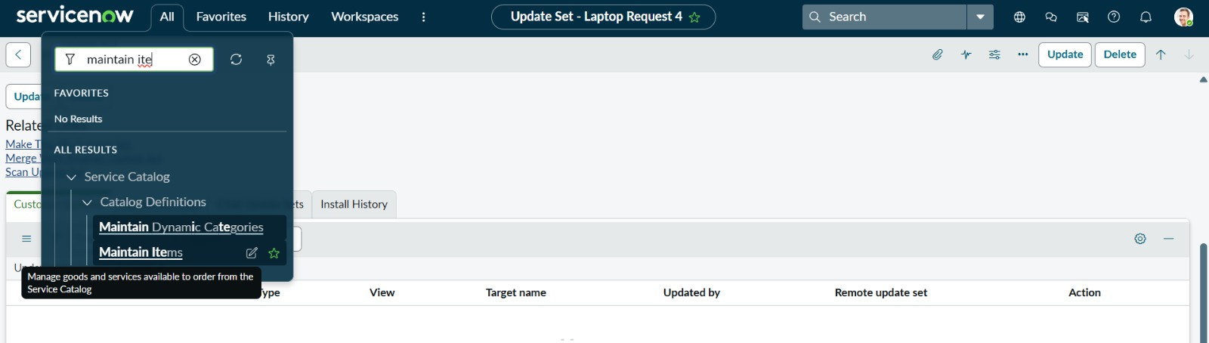

1. **Name:** Laptop Request 3
2. **Catalog:** Service Catalog
3. **Category:** Hardware
4. **Application:** Global
5. **Active:** ✅ Checked
6. **Short Description:** *Use this item to request a new laptop*

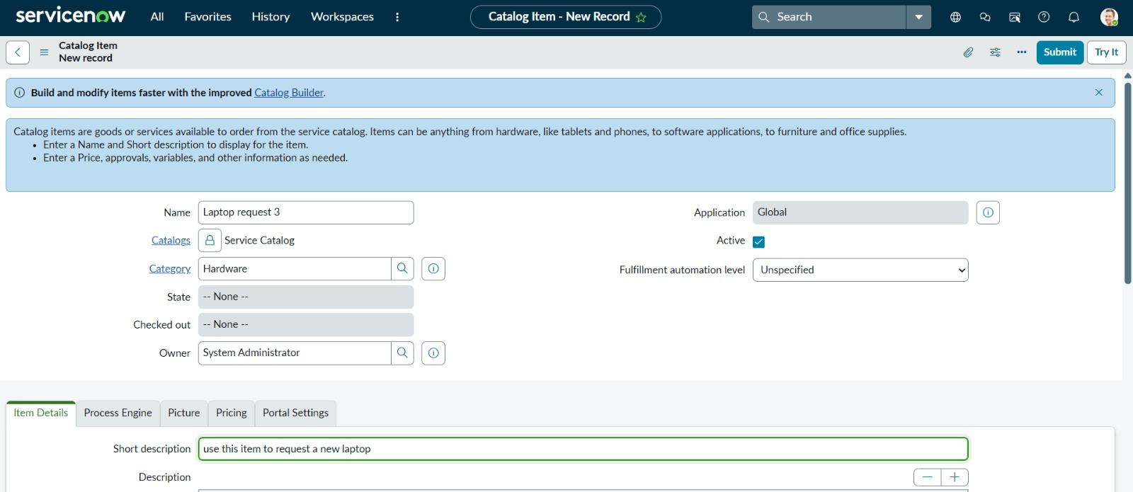Click **Submit** to save the catalog item.

**Milestone 4: Creation of Variables**

**Activity:** Adding Variables to the Catalog Item

1. Go to **All >> Maintain Items >> Open the “Laptop Request 3” catalog item**.
2. In the **Related Links** section, click on **New** under *Variables*.
3. Create the first variable with the details below:
   * **Type:** Single Line Text
   * **Question:** Laptop Model
   * **Name:** laptop_model
   * **Order:** 100  
     This variable is used to enter the laptop model requested.
4. Create the second variable:
   * **Type:** Multi Line Text
   * **Question:** Justification
   * **Name:** justification
   * **Order:** 200  
     This variable is used to write the reason for requesting a new laptop.
5. Create the third variable:
   * **Type:** Check Box
   * **Question:** Additional Accessories
   * **Name:** additional_accessories
   * **Order:** 300  
     This allows the user to select if they need extra accessories.
6. Create the fourth variable:
   * **Type:** Multi Line Text
   * **Question:** Accessories Details
   * **Name:** accessories_details
   * **Order:** 400  
     This variable is used to describe which accessories are needed.
7. After creating each variable, click on **Submit** to save.
8. Open the **Variables** tab under the *Laptop Request 4* catalog item to make sure all four variables are added and active.

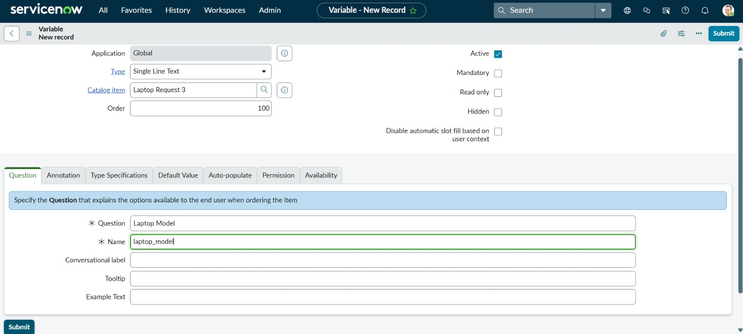

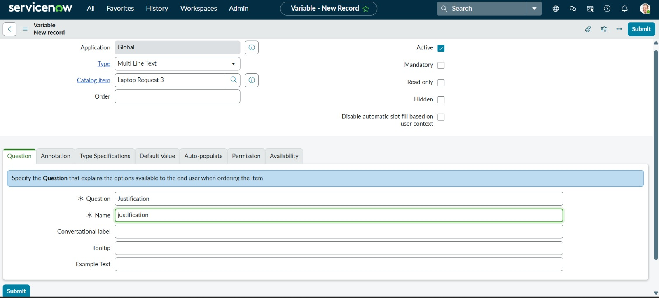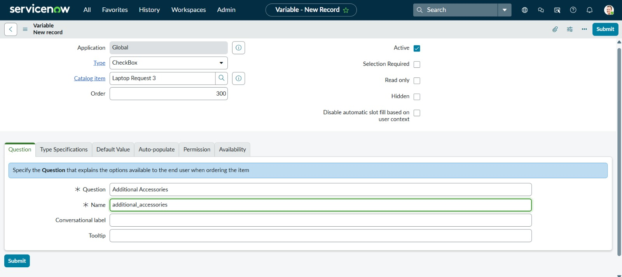

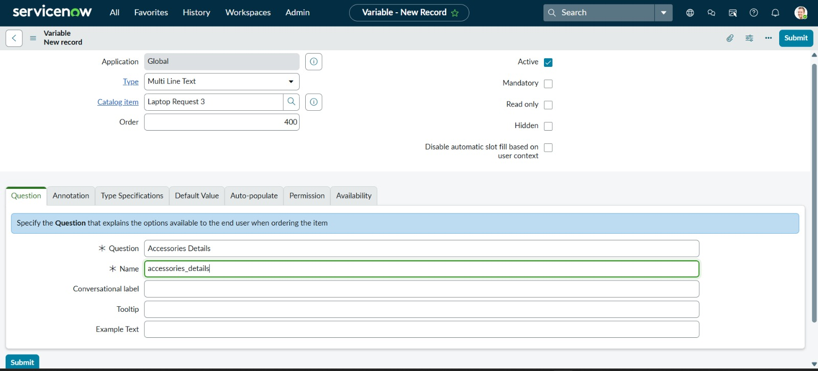

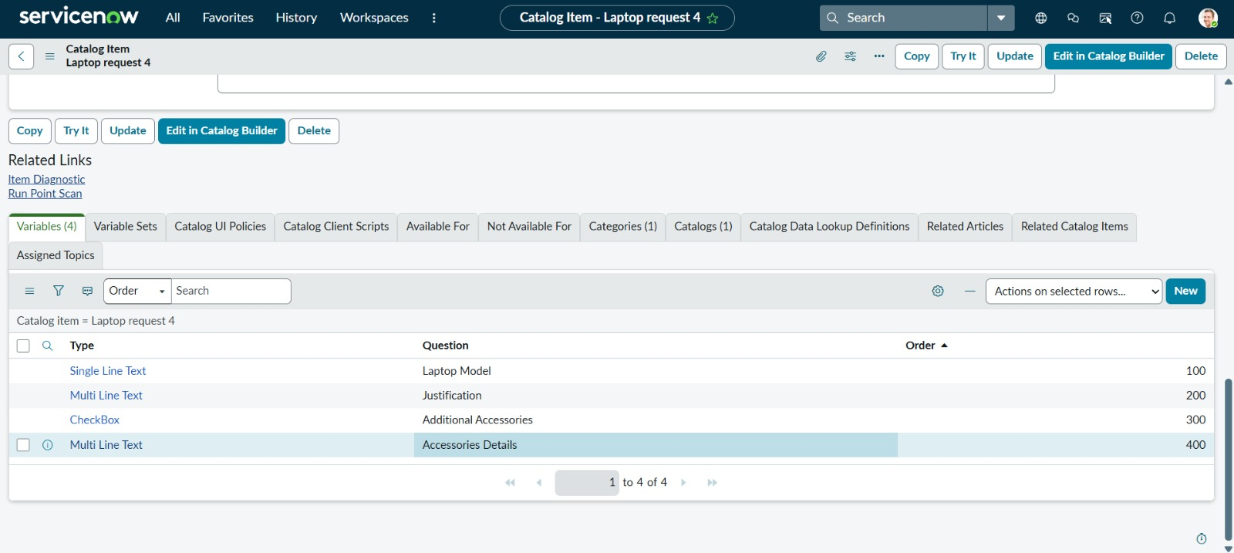

**Milestone 5: Creation of Catalog UI Policy**

**Activity:** Adding Catalog UI Policy for Accessories Details

1. Go to **All >> Catalog UI Policies** from the navigation filter.
2. Click on **New** to create a new policy.
3. Enter the details as below:
   * **Applies to:** A Catalog Item
   * **Catalog Item:** Laptop Request 3
   * **Short Description:** Show Accessories Details
   * **Application:** Global
   * **Active:** Checked
4. In the **When to Apply** section, set the condition:
   * Field: *additional_accessories*
   * Condition: *is*
   * Value: *true*
5. Check **Applies on a Catalog Item view** and **On Load**.
6. Click **Submit** to save the policy.
7. Save all the changes.

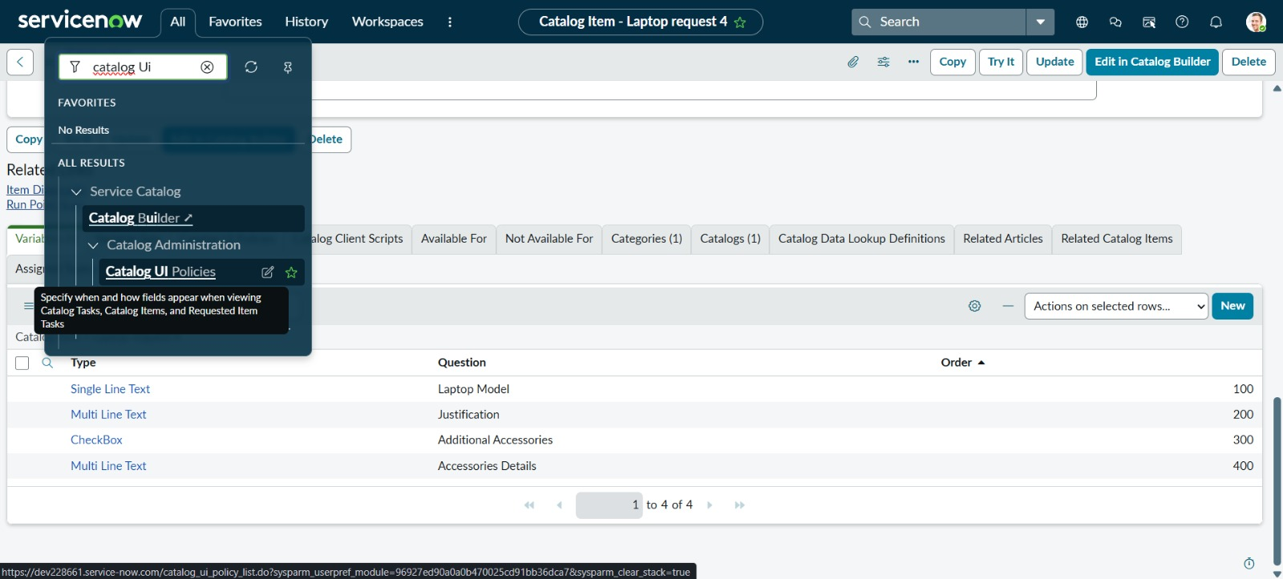

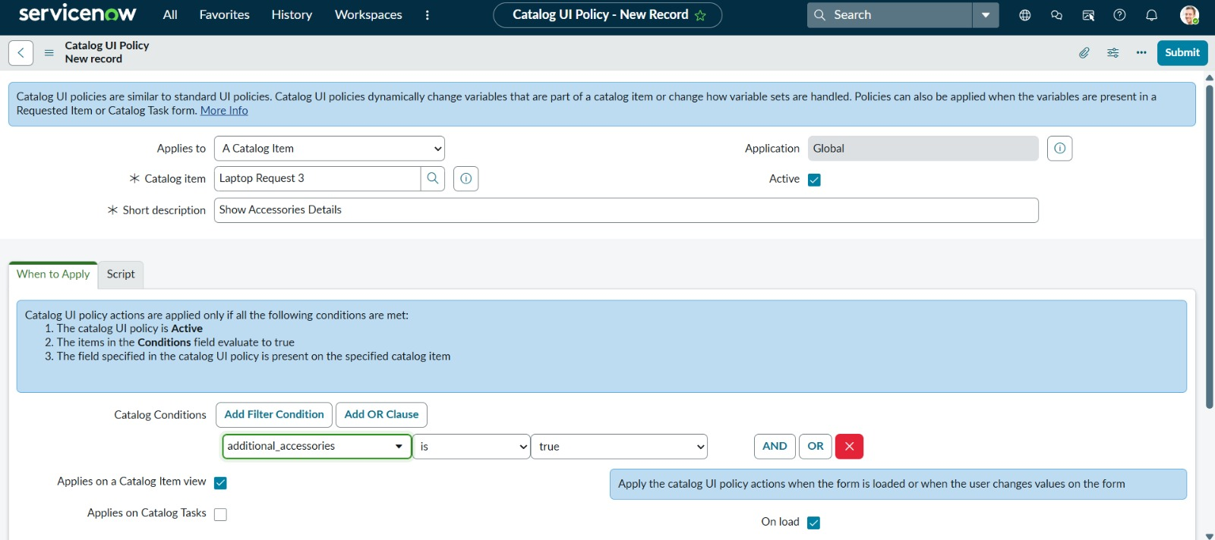

**Milestone 6: Creation of UI Action**

**Activity:** Adding a Reset Form Button

1. Go to **All >> UI Actions** using the navigation filter.
2. Click on **New** to create a new UI Action.
3. Fill in the following details:
   * **Name:** Reset Form 3
   * **Table:** Shopping Cart [sc_cart]
   * **Order:** 100
   * **Action Name:** Reset Form
   * **Active:** Checked
   * **Show Insert:** Checked
   * **Show Update:** Checked
   * **Client:** Checked
4. Scroll down to the **Script** section.
5. Turn on **ECMAScript 2021 (ES12) mode**.
6. In the script editor, type the following code:

function resetForm() {

g_form.clearForm();

alert("The form has been reset");

}

1. Click on **Submit** to save the UI Action.

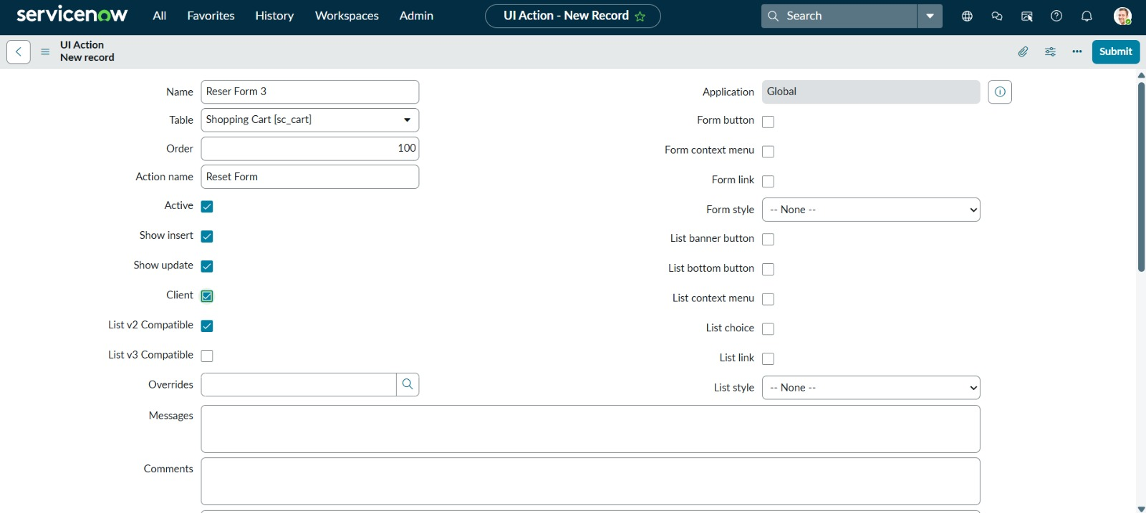

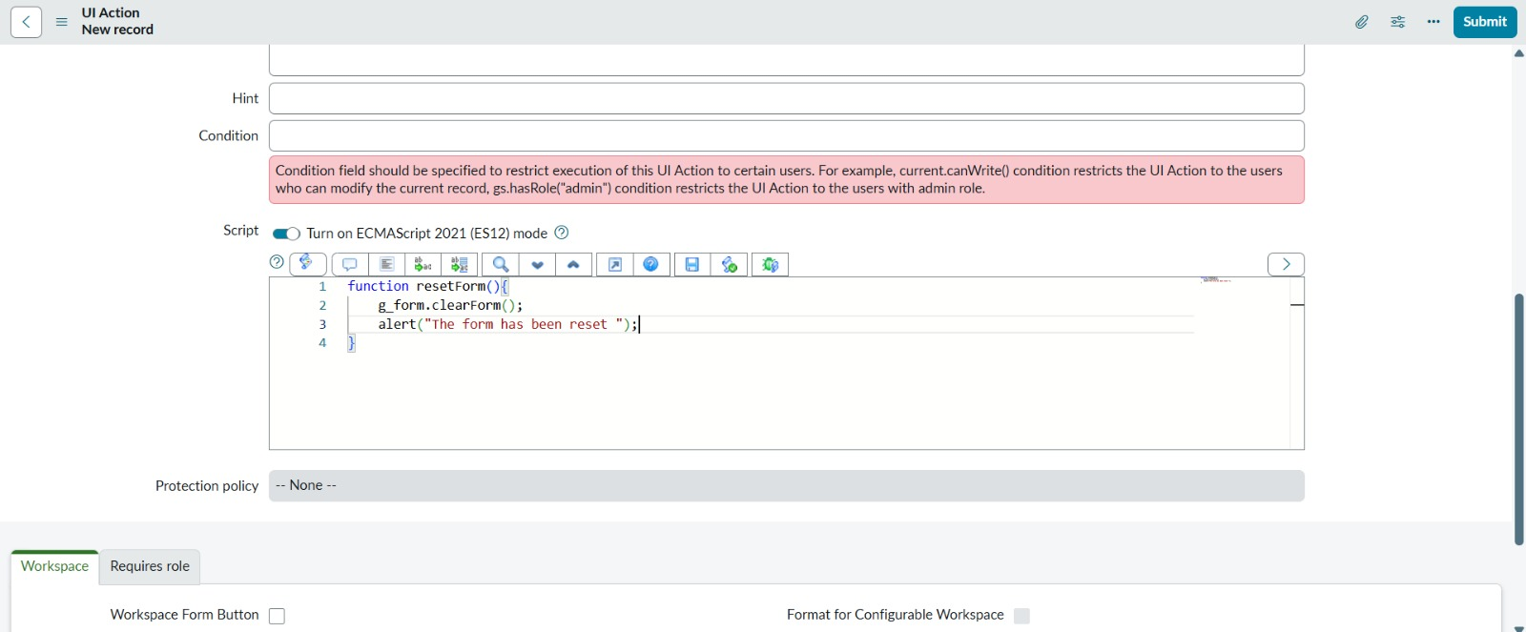

**Milestone 6: Create and Manage Update Set**

**Activity:** Capturing Changes in an Update Set

1. Go to the **Application Navigator** and search for **Update Sets**.
2. Open the **Local Update Sets** list.
3. Click **New** to create a new update set.
4. Enter the following details:
   * **Name:** Laptop Request 3
   * **State:** In Progress
   * Click **Submit**.
5. Now make all required changes in the catalog item (variables, UI policy, UI action).  
   These changes will automatically be captured in the **Laptop Request 3** update set.
6. After completing all the changes, open the **Laptop Request 3** update set.
7. Change the **State** to **Complete**.
8. Add a short **Description** (e.g., “Contains Laptop Request catalog item with variables and UI actions”).
9. Click **Update** to save.

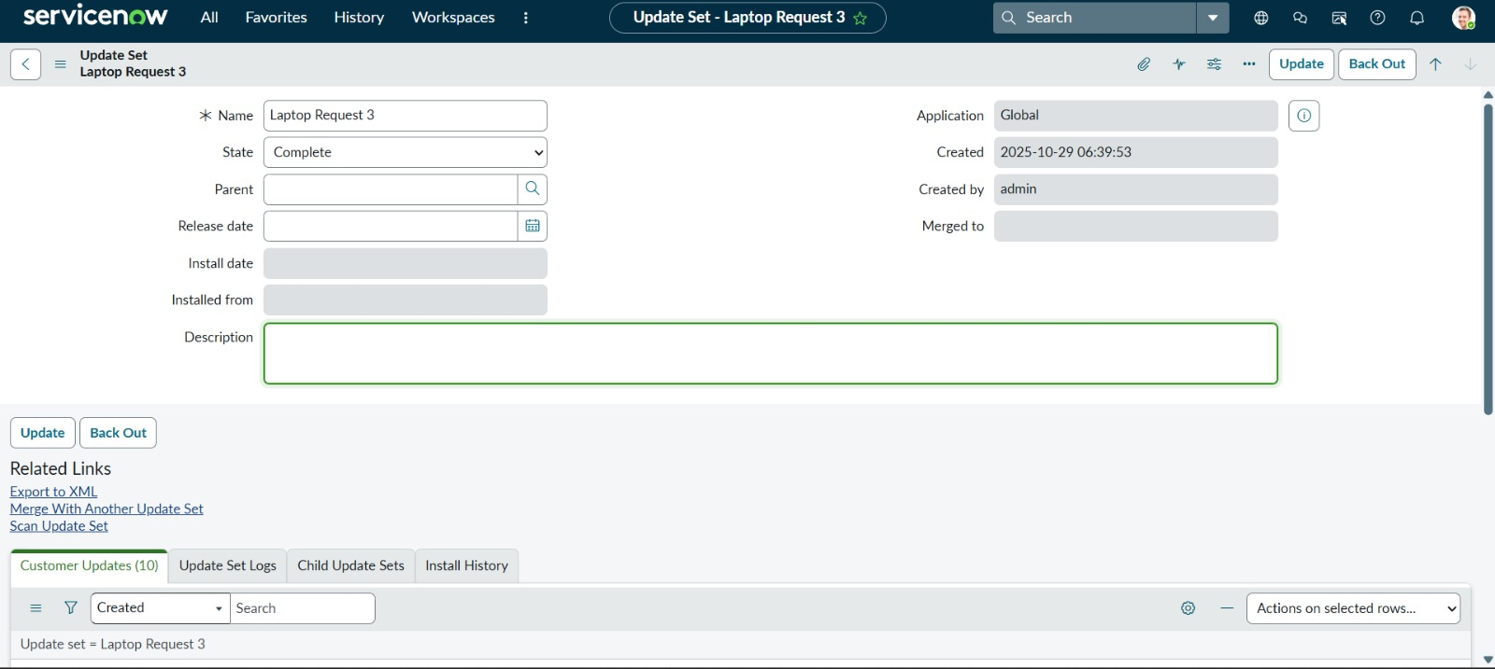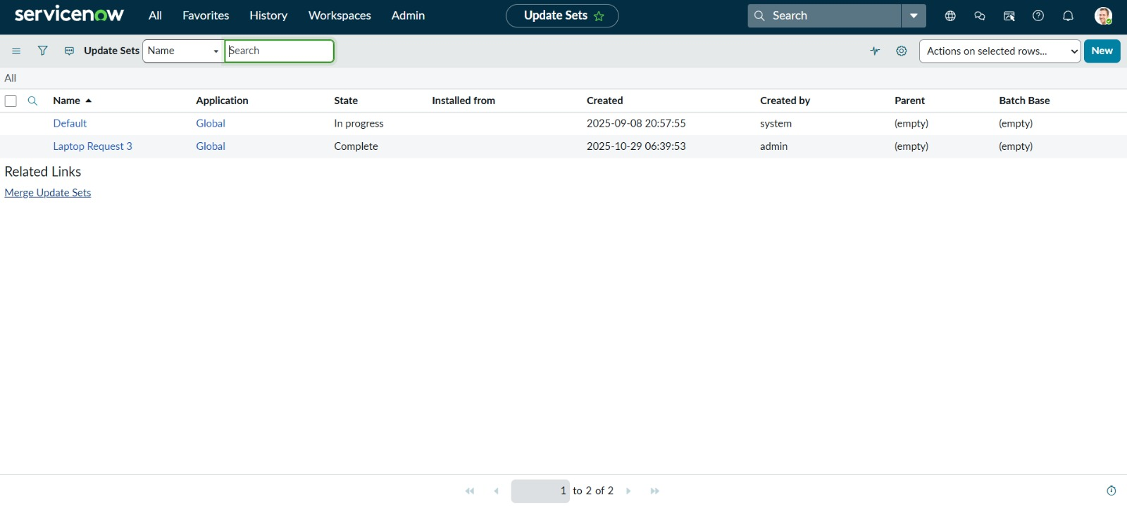

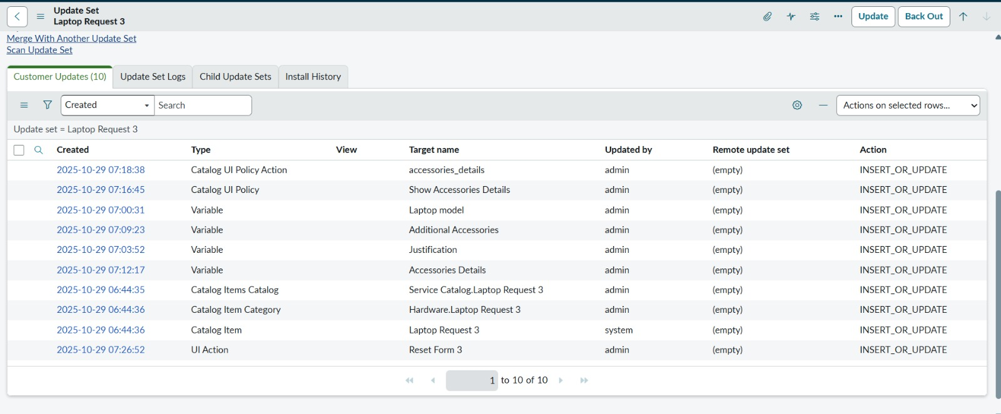

**Milestone 6: Testing and Final Output**

**Activity:** Testing the Laptop Request Catalog Item

After creating and updating all the configurations, the final step is to test the “Laptop Request” catalog item to ensure everything works properly.

**Steps:**

1. Go to **Service Catalog → Hardware** and open **Laptop Request 3**.
2. Fill in the form fields:
   * **Laptop Model:** Enter the laptop name (e.g., HP 15).
   * **Justification:** Mention the reason for requesting the laptop.
   * **Additional Accessories:** Check this box if accessories are required.
   * **Accessories Details:** Enter details (e.g., laptop charger, extension box).
3. Click **Order Now** to submit the request.
4. Once submitted, the **Order Status** page appears with a confirmation message:  
   “✅ Thank you, your request has been submitted.”
5. The page also displays:
   * **Request Number** (e.g., REQ0010001)
   * **Order Placed Date**
   * **Estimated Delivery Date**
6. The submitted request can be tracked from the **Service Catalog Order History**.

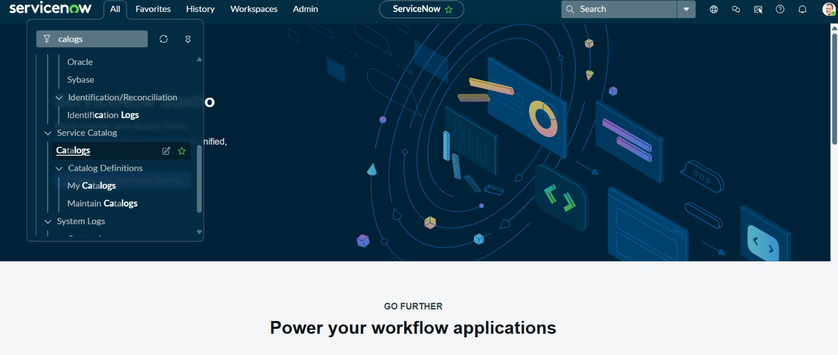

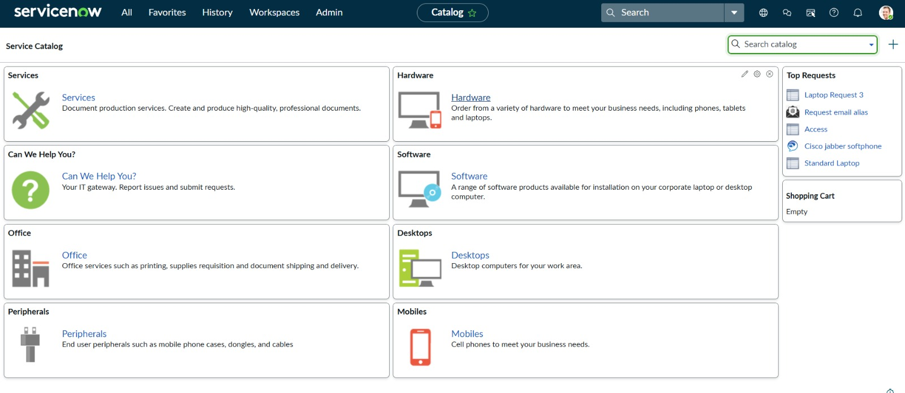

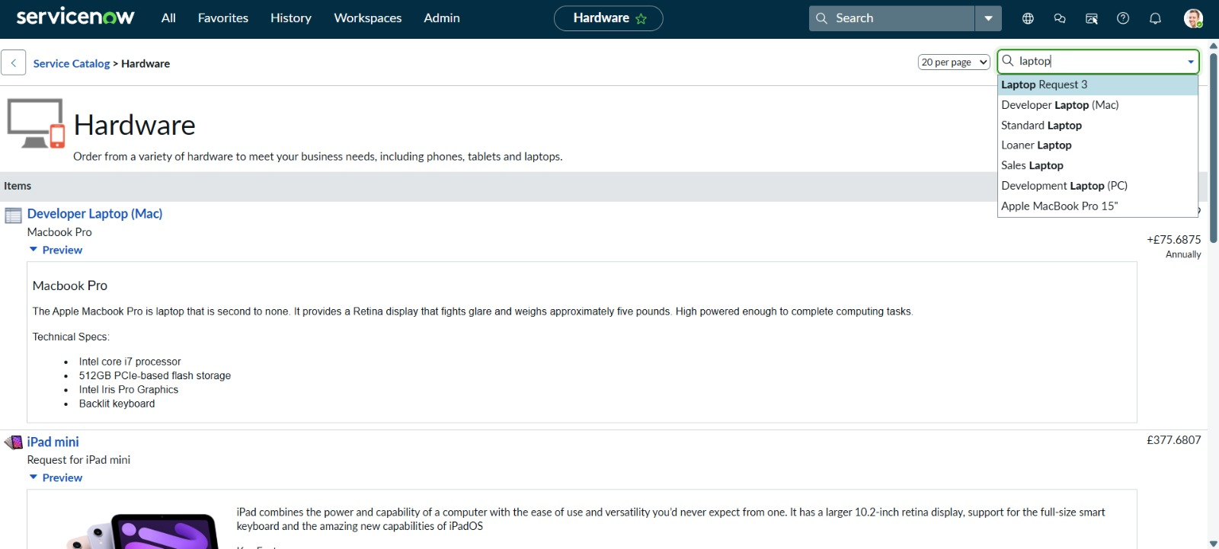

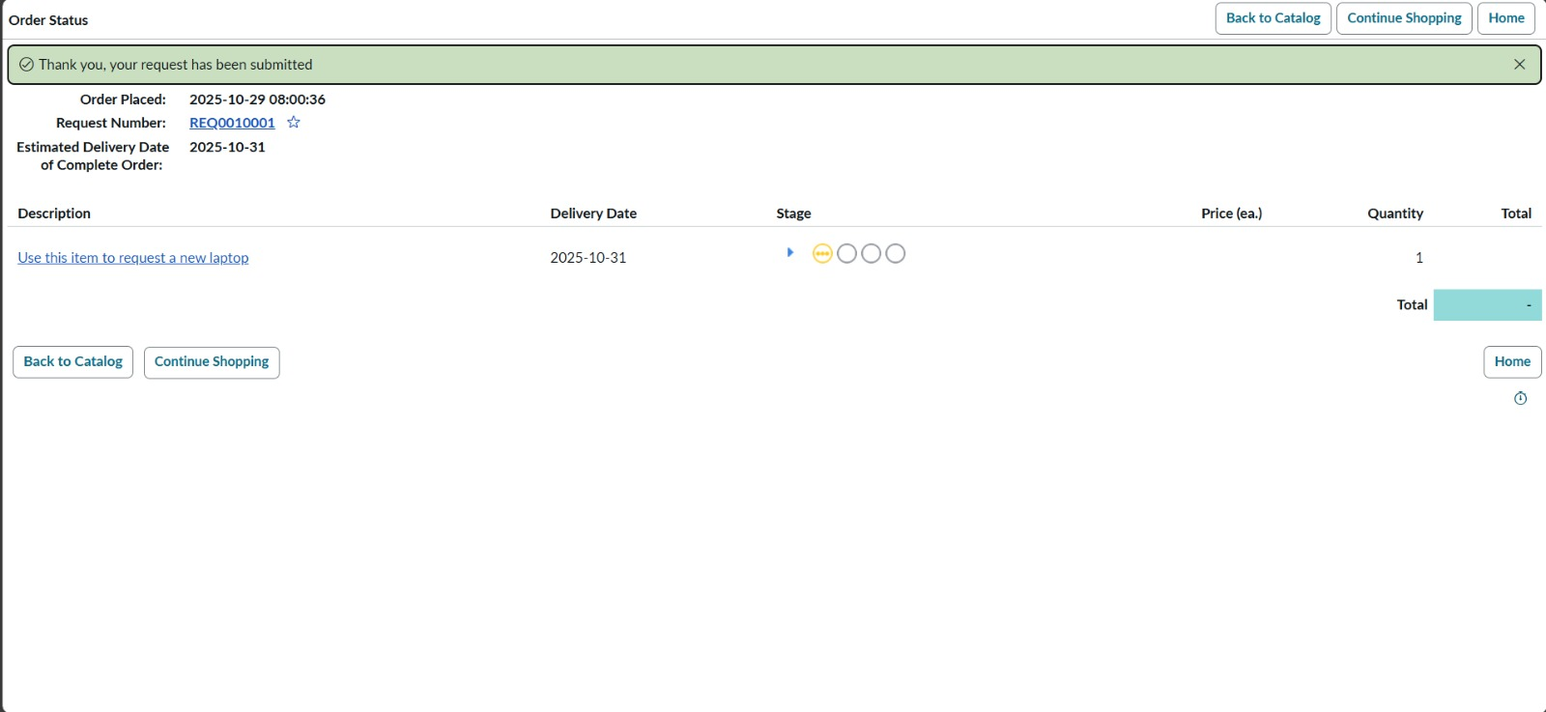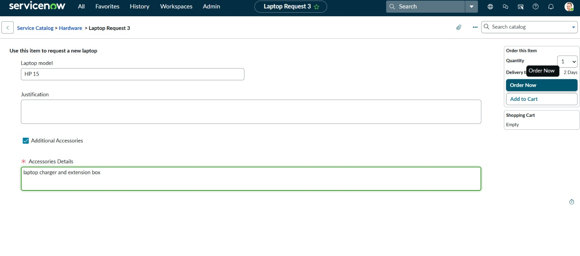

**Conclusion**

The Laptop Request Catalog Project was successfully designed and implemented in the ServiceNow platform. It enables users to easily request laptops and additional accessories through a simple and automated process. All milestones, including catalog creation, variable setup, UI actions, and testing, were completed effectively. The system helps streamline laptop request management, reduces manual work, and improves user experience by providing a faster and more organized service process.